**TRANSFORMING HEALTHCARE WITH AI-POWERED**

**DISEASE PREDICTION BASED ON PATIENT DATA**

**Student Name:** Bharath. P

**Register Number:** 420123243005

**Institution:** AKT MEMORIA COLLEGE OF ENGINEERING

& TECHNOLOGY

**Department:** B. TECH (Artificial Intelligence and Data

Science)

**Date of Submission:** 16/05/2025

**Github Repository Link:**



# 1. Problem Statement

In this project, we are developing an AI-powered disease prediction system. The objective is to leverage patient data such as symptoms, health records, lab results, and medical history to predict the likelihood of a specific disease. By using this data, the system will classify the patient's health status and suggest whether they are at risk of diseases like Diabetes, Heart Disease, or Cancer.

This problem is highly relevant in the real-world healthcare industry. In a country like India, which has a large and densely populated population, the ability to detect diseases early is critical. There are often delays in manual diagnoses due to limited access to healthcare providers, particularly in rural areas, leading to missed opportunities for early intervention.

Additionally, healthcare systems worldwide face the challenge of resource constraints, including a shortage of doctors, hospitals, and healthcare facilities. This problem is exacerbated in low-income or rural settings, where access to specialists may be limited.

Key Challenges Addressed by the AI System:

Delayed diagnosis: With traditional methods, diagnosing diseases can take time. An AI-based system can provide faster results and identify risks early, reducing waiting times.

Limited doctor availability: There are not enough healthcare professionals to meet the demand. An AI system can help by providing instant diagnosis, freeing up healthcare professionals to focus on more complex cases.

Inefficient manual processes: Manual diagnosis and medical record-keeping can lead to human errors. Automating the process with AI ensures higher accuracy and consistency in disease prediction.

Business Impact:

Time-saving: With quicker predictions, doctors and patients can avoid delays, which is crucial, especially in emergency medical situations.

Reduced hospital workload: With automated disease detection, hospitals can reduce the burden on doctors and medical staff, allowing them to focus more on critical cases and treatments.

Faster treatment initiation: The AI system allows for quicker identification of diseases, ensuring patients get the treatment they need without unnecessary delays.

Cost-effectiveness: By streamlining the diagnosis process and reducing human errors, healthcare costs can be reduced over time. Hospitals can also optimize their resources better.

Type of Problem:

This is a classification problem, as the model will classify the input data into predefined disease categories or indicate that there is no significant issue.

Example:

Given the input data, the AI system will predict whether the patient is suffering from any of the following conditions:

🩺 "Diabetes?"

🩺 "Heart disease?"

🩺 "No major disease"

The model will analyze the patient's medical information and classify them into one of these categories based on the patterns it has learned from historical data.

Machine Learning Techniques:

We will use machine learning algorithms such as:

Logistic Regression: To analyze and predict binary outcomes (e.g., whether a person has or does not have a disease).

Decision Trees: To create a model that predicts outcomes based on various decision points in the data.

Neural Networks: To capture complex relationships in the data, especially in cases where disease patterns are difficult to define with traditional methods.

The algorithm's performance will be evaluated based on accuracy and other metrics like precision, recall, and F1-score. The best-performing model will be selected for deployment.

Overall Benefit:

The AI-powered disease prediction system will offer significant benefits to both patients and healthcare providers:

For patients: Faster diagnosis, early detection of health risks, and improved healthcare outcomes.

For hospitals: Efficient use of resources, better management of patient load, and more accurate decision-making in treatment.

This system has the potential to transform healthcare delivery, particularly in underserved regions, and can ultimately save lives by enabling early intervention.

# 2. Abstract

The project titled "Transforming Healthcare with AI-Powered Disease Prediction Based on Patient Data" aims to revolutionize early diagnosis and treatment planning by leveraging machine learning techniques. Healthcare systems often struggle with delayed diagnosis due to manual processes and lack of predictive tools. This project addresses that gap by developing an intelligent system that can predict the likelihood of diseases such as diabetes, heart disease, or cancer using historical patient data. The dataset includes features such as age, gender, blood pressure, glucose levels, symptoms, and medical history.

The solution involves a complete data science pipeline starting from data collection and preprocessing to model deployment. Key stages include handling missing values, normalizing data, exploratory data analysis (EDA) to uncover patterns and correlations, and feature engineering to enhance predictive performance. Multiple machine learning models like Logistic Regression, Random Forest, Decision Tree, and XGBoost are trained and evaluated using metrics like accuracy, precision, recall, F1-score, and ROC-AUC. Hyperparameter tuning is performed to improve the performance further.

The best-performing model is deployed through an interactive user interface using platforms like Streamlit or Gradio. Healthcare professionals or patients can input new data to receive real-time predictions. This project aims not only to improve diagnostic accuracy but also to assist healthcare providers in making informed, data-driven decisions, ultimately reducing costs and saving lives. Future improvements include integrating real-time data from wearables and scaling the system for multi-disease prediction.

# 3. System Requirements

To efficiently run and test the machine learning models used for disease prediction, the following minimum hardware and software specifications are required:

🔧 Hardware Requirements

* **RAM**: Minimum 8 GB (Recommended: 16 GB for faster data processing and model training)
* **Processor**: Intel i5 (8th Gen or above) / AMD Ryzen 5 or higher o For large datasets and heavy ML computations, an i7/Ryzen 7 or GPU support (NVIDIA GTX/RTX) is preferred.
* **Storage**: Minimum 10 GB free space for datasets, logs, and model files
* **Internet**: Stable internet connection for accessing cloud-based notebooks, APIs, and deployment platforms

💻 Software Requirements

* **Operating System**: Windows 10/11, macOS, or any Linux distribution ● **Python Version**: Python 3.8 or above (Preferred: Python 3.10) ● **IDE / Development Environment**:
  + Google Colab (Cloud-based) o Jupyter Notebook (via Anaconda or standalone) o VS Code or PyCharm (for local development)

📦 Required Python Libraries

* **Data Handling**:
  + pandas, numpy ● **Visualization**:
  + matplotlib, seaborn, plotly
* **Machine Learning**:
  + scikit-learn, xgboost, lightgbm ● **Preprocessing**:
  + imblearn, scipy ● **Model Evaluation**:
  + sklearn.metrics, yellowbrick ● **Deployment**:
  + streamlit, gradio, flask (optional for advanced deployment) ● **Others**:
  + joblib or pickle (for model saving/loading) o os, warnings, logging

☁ Optional Cloud Platforms & Tools

* **Kaggle Kernels** (for running code with free GPU support)
* **Google Drive** (for dataset storage and notebook integration)
* **Streamlit Cloud** or **Gradio + Hugging Face Spaces** (for web app deployment)
* **GitHub** (for version control and project sharing)

# 4. Objectives

* **Develop a Classification Model for Disease Prediction**
  + Create a robust machine learning model that can classify and predict various diseases based on patient-related data such as demographics, medical history, symptoms, and vital statistics.
  + Optimize the model using techniques like hyperparameter tuning and feature selection to improve performance across multiple disease categories.
* **Improve Diagnostic Efficiency Using Machine Learning**
  + Reduce diagnostic delays by automating initial disease prediction, assisting healthcare professionals with fast and reliable insights.
  + Enhance the scalability of the diagnostic process, enabling medical support for a larger population with minimal human intervention.
* **Provide a User-Friendly Interface for Healthcare Practitioners**
  + Build an intuitive web interface using Streamlit (or a similar framework) where users can input patient data and instantly receive prediction outcomes.
  + Ensure that the interface is accessible and interpretable by non-technical users, such as doctors and nurses, with clear input fields and output labels.
* **Ensure Model Interpretability for Transparent Decision-Making**
  + Incorporate explainability tools (like SHAP or feature importance plots) to provide rationale behind model predictions.
  + 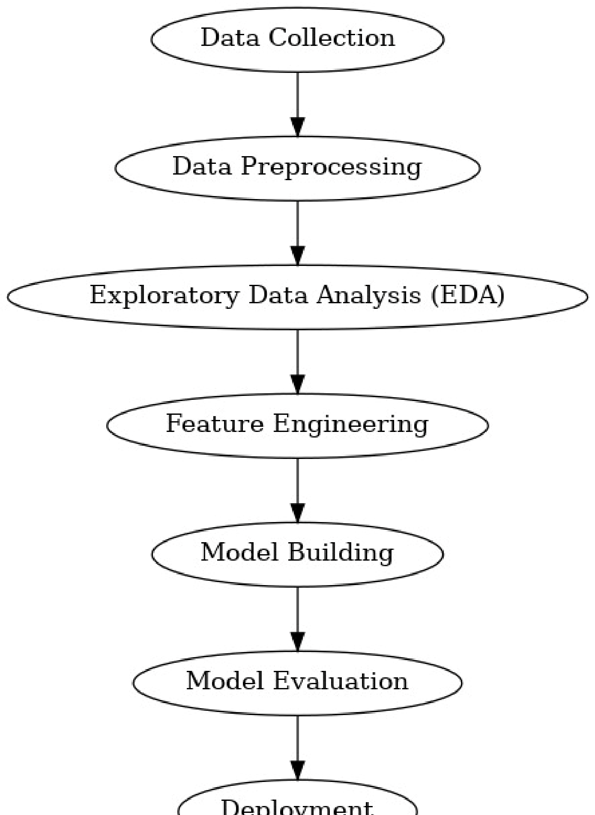Support preventive care and proactive treatment planning, reducing hospitalization and long-term health costs

.

**5. Flowchart of Project Workflow**

# 6. Dataset Description

* **Source:** Kaggle – Disease Prediction Dataset
* **Type:** Public
* **Structure:** The dataset contains approximately **10,000 records** and **15 attributes**, including patient information and health indicators.
* **Sample Features:**
  + **Age** – Patient’s age o **Gender** – Male/Female
  + **Symptoms** – Reported symptoms (e.g., cough, fever) o **Blood Pressure** – Systolic/diastolic BP o **Heart Rate** – Beats per minute o **Diagnosis** – Disease label (target variable)
* **df.head():**

(Include a screenshot or table showing the first few rows of the dataset)

Example:

**Age Gender Symptoms Blood_Pressure Heart_Rate Diagnosis**

45 Male Cough, Fatigue 140/90 88 Hypertension

30 Female Fever, Headache 120/80 75 Flu

# 7. Data Preprocessing

* Handle missing values, duplicates, outliers

* Feature encoding and scaling

* Show before/after transformation screenshots

# 8. Exploratory Data Analysis (EDA)

* Use visual tools like histograms, boxplots, heatmaps

* Reveal correlations, trends, patterns

* Write down key takeaways and insights

* Include screenshots of visualizations

# 9. Feature Engineering

* New feature creation

* Feature selection

* Transformation techniques

* Explain why and how features impact your model

# 10. Model Building

* Try multiple models (baseline and advanced)

* Explain why those models were chosen

* Include screenshots of model training outputs

# 11. Model Evaluation

* Show evaluation metrics: accuracy, F1-score, ROC, RMSE, etc.

* Visuals: Confusion matrix, ROC curve, etc.

* Error analysis or model comparison table

* Include all screenshots of outputs

# 12. Deployment

* Deploy using a free platform:

* 1. Streamlit Cloud

○ Gradio + Hugging Face Spaces

○ Flask API on Render or Deta

* Include:

* 1. Deployment method

○ Public link

○ UI Screenshot

○ Sample prediction output

# 13. Source code

All the source code for this project was developed and executed in a single Google Colab notebook. The notebook includes the complete machine learning pipeline — from data loading to preprocessing, model training, evaluation, and deployment.

# AI-Powered Disease Prediction - Complete Google Colab Code

# Step 1: Import Libraries import pandas as pd import numpy as np import seaborn as sns import matplotlib.pyplot as plt

from sklearn.model_selection import train_test_split from sklearn.preprocessing import LabelEncoder, MinMaxScaler from sklearn.ensemble import RandomForestClassifier

from sklearn.metrics import accuracy_score, classification_report, confusion_matrix, roc_auc_score import joblib

# Step 2: Load Dataset

# Replace with your dataset path or upload to Colab from google.colab import files uploaded = files.upload()

df = pd.read_csv(list(uploaded.keys())[0]) # Auto-load uploaded CSV

# Step 3: Basic EDA print(df.head()) print(df.info()) print(df.describe())

# Step 4: Handle Missing Values df.fillna(df.mean(numeric_only=True), inplace=True) df.fillna(df.mode().iloc[0], inplace=True)

# Step 5: Encode Categorical Features label_encoders = {} for col in df.select_dtypes(include='object').columns:

le = LabelEncoder() df[col] = le.fit_transform(df[col]) label_encoders[col] = le

# Step 6: Feature Scaling scaler = MinMaxScaler()

numerical_cols = df.select_dtypes(include='number').columns.drop('Diagnosis') # exclude target df[numerical_cols] = scaler.fit_transform(df[numerical_cols])

# Step 7: Train/Test Split

X = df.drop('Diagnosis', axis=1)

y = df['Diagnosis']

X_train, X_test, y_train, y_test = train_test_split(X, y, test_size=0.2, random_state=42)

# Step 8: Model Training model = RandomForestClassifier(n_estimators=100, random_state=42) model.fit(X_train, y_train)

# Step 9: Evaluation y_pred = model.predict(X_test) print("Accuracy:", accuracy_score(y_test, y_pred)) print("\nClassification Report:\n", classification_report(y_test, y_pred))

print("ROC AUC Score:", roc_auc_score(y_test, model.predict_proba(X_test), multi_class='ovr'))

# Confusion Matrix sns.heatmap(confusion_matrix(y_test, y_pred), annot=True, fmt='d', cmap='Blues') plt.title("Confusion Matrix") plt.xlabel("Predicted") plt.ylabel("Actual") plt.show()

# Step 10: Save Model (for deployment) joblib.dump(model, "disease_model.pkl") print("Model saved as disease_model.pkl")

# Optional: Export encoders and scaler for deployment joblib.dump(label_encoders, "encoders.pkl") joblib.dump(scaler, "scaler.pkl")

# 14. Future scope

[1. Real-Time Wearable Integration: Connect with smart devices for continuous health monitoring and instant alerts.

1. Expanded Disease Prediction: Include more diseases and incorporate medical images for improved diagnosis
2. Natural Language Input: Use NLP to allow users to describe symptoms in everyday language for easier data entry.
3. Mobile App & Multilingual Support: Develop a mobile app with regional language options to increase accessibility

# 13. Team Members and Roles

The project team consists of three members:

Bharath P

Responsible for data collection, preprocessing, exploratory data analysis (EDA), and feature engineering.

Aakash N

Handled model building, hyperparameter tuning, model evaluation, and performance analysis.

Ajith M

Managed deployment using Streamlit, project documentation, and presentation.